System equations

$$\dot{z}=v_{z}$$

$${\dot{v}}_{z}=\frac{D}{m}-g$$

$$\dot{β}=0$$

---

$D=\frac{1}{2}⋅ρ⋅v_{z}^{2}⋅s⋅c_{D}$ Drag force

$β=\frac{m}{c_{D}⋅s}$ Ballistic coefficient

$$D=\frac{m}{2⋅β}⋅ρ⋅v_{z}^{2}$$

$ρ=0.0034⋅e^{-\frac{1}{22,000}⋅z}$ air density

$$D=\frac{m}{2⋅β}⋅0.0034⋅e^{-\frac{1}{22,000}⋅z}⋅v_{z}^{2}$$

---

**Nonlinear model**

$$x=f(x)$$

$$\dot{z}=v_{z}$$

$${\dot{v}}_{z}=\frac{0.0034}{2}⋅e^{-\frac{1}{22,000}⋅z}⋅v_{z}^{2}⋅\frac{1}{β}-g$$

$$\dot{β}=0$$

$x_{0}=[z_{0},v_{z_{0}}, β_{0}]$**initial conditions**

For simplicity assume constant density: $ρ=0.0034$

$$\dot{z}=v_{z}$$

$${\dot{v}}_{z}=\frac{0.0034}{2⋅β}⋅v_{z}^{2}-g$$

$$\dot{β}=0$$

reference trajectory

$x_{n}=[v_{z_{n}}⋅t, v_{z_{n}},β_{0}]$ nominal solution

Where $v_{z_{n}}$ is such that $\frac{0.0034⋅v_{z_{n}}^{2}}{2⋅β_{0}}=g→v_{z_{n}}=-\sqrt{\frac{2⋅β_{0}⋅g}{0.0034}}$

${\dot{x}}_{n}=[v_{z_{n}},0, 0]$ test solution.

substitution of $x_{n}$ to the diff equations:

$$\dot{z}=-\sqrt{\frac{2⋅β_{0}⋅g}{0.0034}}=v_{z_{n}}$$

$${\dot{v}}_{z}=\frac{0.0034}{2⋅β_{0}}⋅\frac{2⋅β_{0}⋅g}{0.0034}-g=0$$

$$\dot{β}=0$$

Correct.

Linearization

$$\frac{∂f}{∂x}=\left(\begin{matrix}0 & 1 & 0 \\ 0 & \frac{0.0034}{β}⋅v_{z} & -\frac{0.0034}{2⋅β^{2}}⋅v_{z}^{2} \\ 0 & 0 & 0\end{matrix}\right)$$

$$\frac{∂f}{∂x}{\left.​\right|}_{x_{n}}=\left(\begin{matrix}0 & 1 & 0 \\ 0 & -\frac{0.0034}{β_{0}}⋅\sqrt{\frac{2⋅β_{0}⋅g}{0.0034}} & -\frac{0.0034}{2⋅β_{0}^{2}}⋅{\left(-\sqrt{\frac{2⋅β_{0}⋅g}{0.0034}}\right)}^{2} \\ 0 & 0 & 0\end{matrix}\right)$$

$$=\left(\begin{matrix}0 & 1 & 0 \\ 0 & -\sqrt{\frac{2⋅0.0034⋅g}{β_{0}}} & -\frac{g}{β_{0}} \\ 0 & 0 & 0\end{matrix}\right)$$

Linearized equations:

$$\dot{z}=v_{z}$$

$${\dot{v}}_{z}=-\sqrt{\frac{2⋅0.0034⋅g}{β_{0}}}⋅v_{z}-\frac{g}{β_{0}}⋅β$$

$$\dot{β}=0$$

Comparison: linear vs. simplified nonlinear system

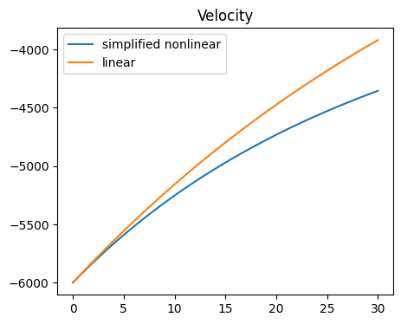

Wrt full nln system:

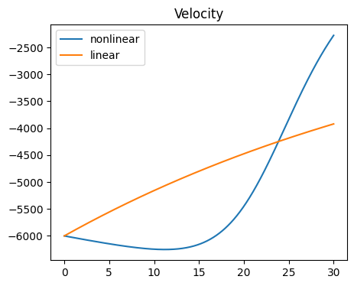

Simplification #2

Let’s approximate the density function with a first order equation:

$ρ(z)=0.0034⋅e^{-\frac{1}{22,000}⋅z}$ air density

x0, y­0

$$f\left(x\right)=.0034⋅e^{-\frac{x}{22000}}$$

$$x_{n}=z_{0}$$

f(xn)

f(xn+dx)

x, y

$$y=y_{0}+m⋅(x-x_{0})$$

$$f\left(x_{n}+δx\right)-f\left(x_{n}\right)=f_{x}^{'}\left(x_{n}\right)⋅δx$$

$$f\left(x\right)=f\left(x_{n}\right)+f_{x}^{'}\left(x_{n}\right)⋅x$$

xn xn+dx

$$f\left(z_{0}\right)=.0034⋅e^{-\frac{z_{0}}{22000}}$$

$$f_{x}^{'}=-\frac{.0034}{22000}⋅e^{-\frac{x}{22000}}$$

$$f_{x}^{'}{\left.​\right|}_{z_{0}}=-\frac{.0034}{22000}⋅e^{-\frac{z_{0}}{22000}}$$

$$f\left(x\right)=.0034⋅e^{-\frac{z_{0}}{22000}}-\frac{.0034}{22000}⋅e^{-\frac{z_{0}}{22000}}⋅x$$

$$ρ(z)=.0034⋅e^{-\frac{z_{0}}{22000}}⋅\left(1-\frac{1}{22000}\right)⋅z$$

Then the simplified nonlinear #2 system is:

$$\dot{z}=v_{z}$$

$${\dot{v}}_{z}=\frac{1}{2⋅β}⋅.0034⋅e^{-\frac{z_{0}}{22000}}⋅\left(1-\frac{1}{22000}\right)⋅z⋅v_{z}^{2}-g$$

$$\dot{β}=0$$

reference trajectory

$x_{n}=[v_{z_{n}}⋅t, v_{z_{n}},β_{0}]$ nominal solution

Where $v_{z_{n}}$ is such that $\frac{1}{2⋅β}⋅.0034⋅e^{-\frac{z_{0}}{22000}}⋅\left(1-\frac{1}{22000}\right)⋅z⋅v_{z}^{2}=g→v_{z_{n}}=\sqrt[3]{\frac{g}{t}⋅\frac{2⋅β_{0}}{.0034⋅e^{-\frac{z_{0}}{22000}}⋅\left(1-\frac{1}{22000}\right)}}$

$${\dot{x}}_{n}=\left[v_{z_{n}},0,0\right]$$

substitution of $x_{n}$ to the diff equations:

$$\dot{z}=v_{z_{n}}$$

$${\dot{v}}_{z}=\frac{1}{2⋅β_{0}}⋅.0034⋅e^{-\frac{z_{0}}{22000}}⋅\left(1-\frac{1}{22000}\right)⋅v_{z}^{3}⋅t-g=0$$

$$\dot{β}=0$$

Correct.

Linearization

Let $a=\frac{1}{2}⋅.0034⋅e^{-\frac{z_{0}}{22000}}⋅\left(1-\frac{1}{22000}\right)$

$$\frac{∂f}{∂x}=\left(\begin{matrix}0 & 1 & 0 \\ a⋅\frac{1}{β}⋅v_{z}^{2} & 2⋅a⋅\frac{1}{β}⋅z⋅v_{z} & -a⋅z⋅\frac{1}{β^{2}}⋅v_{z}^{2} \\ 0 & 0 & 0\end{matrix}\right)$$

$$\frac{∂f}{∂x}{\left.​\right|}_{x_{n}}=\left(\begin{matrix}0 & 1 & 0 \\ a⋅\frac{1}{β_{0}}⋅v_{z_{n}}^{2} & 2⋅a⋅\frac{1}{β_{0}}⋅v_{z_{n}}^{2}⋅t & -a⋅t⋅\frac{1}{β_{0}^{2}}⋅v_{z_{n}}^{3} \\ 0 & 0 & 0\end{matrix}\right)$$

Linear system:

$$\dot{z}=v_{z}$$

$${\dot{v}}_{z}=a⋅\frac{1}{β_{0}}⋅v_{z_{n}}^{2}⋅z+2⋅a⋅\frac{1}{β_{0}}⋅v_{z_{n}}^{2}⋅t⋅v_{z}-a⋅t⋅\frac{1}{β_{0}^{2}}⋅v_{z_{n}}^{3}⋅β$$

Where

$$v_{z_{n}}=\sqrt[3]{\frac{g}{t}⋅\frac{2⋅β_{0}}{.0034⋅e^{-\frac{z_{0}}{22000}}⋅\left(1-\frac{1}{22000}\right)}}$$

$$a=\frac{1}{2}⋅.0034⋅e^{-\frac{z_{0}}{22000}}⋅\left(1-\frac{1}{22000}\right)$$

This solution is very bad how can we set v?

Linearized equations:

$$\dot{z}=v_{z}$$

$${\dot{v}}_{z}=-\sqrt{\frac{2⋅0.0034⋅g}{β_{0}}}⋅v_{z}-\frac{g}{β_{0}}⋅β$$

$$\dot{β}=0$$

This linear system is nonobservable.

Let’s separate:

$${\dot{v}}_{z}=-\sqrt{\frac{2⋅0.0034⋅g}{β_{0}}}⋅v_{z}-\frac{g}{β_{0}}⋅β$$

$$\dot{β}=0$$

$$\dot{z}=v_{z}$$

And try to observe only the higher yellow paert.

זה לא יעבוד כי המדידה היא על המיקום ואם לוקחים רק את הגובה ואת המקדם הבליסטי אז מטריצת הדינמיקה ריקה.